Homework for week 2, submission deadline 23:59 on Sunday night.
- Choose your own topics from following list or your own.
- Gut microbiota and metabolic disease
- Single-cell transcriptomics in cancer immunology
- Antibiotic resistance genomics
- Epigenetic regulation in neurological disorders
- Muscle regeneration and aging ← Topic 5 (chosen)
- Proteomic biomarkers in MAFLD/MASH
Finish the following question section we covered in the class
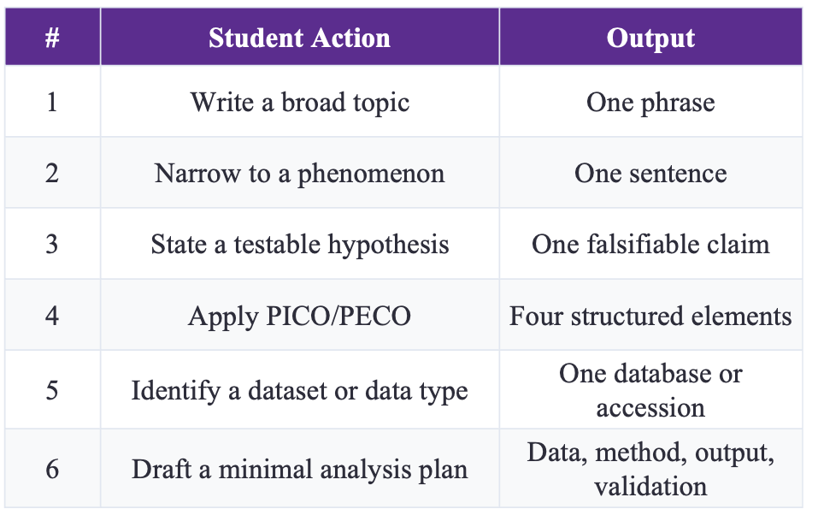

# | Student Action | Output
1 | Write a broad topic | Muscle regeneration and aging
2 | Narrow to a phenomenon | Skeletal-muscle satellite cell function declines with aging, leading to impaired muscle regeneration after muscle injury.
3 | State a testable hypothesis | Upregulation of senescence-associated transcriptional programs in aged satellite cells is negatively associated with skeletal muscle regenerative capacity after injury, after adjusting for injury severity.
4 | Apply PECO | P: Satellite cells isolated from young and aged mouse skeletal muscle after experimental muscle injury.E: Expression level of senescence-associated transcriptional programs in muscle satellite cells (measured by single-cell transcriptomics).C: Satellite-cell populations with high senescence-associated program expression versus populations with low senescence-associated program expression; young mice versus aged mice.O: Skeletal muscle regenerative capacity, including regenerative myofiber formation and expression of muscle-repair-related genes.Covariate: sampling time-point post-muscle injury
5 | Identify a dataset or data type | Dataset source: GEO (Gene Expression Omnibus); Data type: single-cell RNA-seq (scRNA-seq) data of muscle satellite cells from young and aged mice with experimental muscle injury; metadata includes mouse age and post-injury sampling time point.
6 | Draft a minimal analysis plan | Data: Download scRNA-seq dataset from GEO; filter out low-quality cells; retain annotated satellite-cell populations from young and injured aged mice. Use injury-sampling time as major covariate.Method: Perform scRNA-seq standard pre-processing, cell-type annotation for satellite cells. Calculate module score for senescence-associated transcriptional programs and muscle-regeneration gene programs. Test correlation between senescence module score and regeneration module score, adjusting for post-injury sampling time. Apply Benjamini-Hochberg FDR correction for multiple testing.Output: UMAP visualization of satellite-cell populations; violin plots showing senescence-program module score distribution; scatter plot of senescence-module score against regeneration-module score; summary table with adjusted statistical p-values.Validation: Repeat correlation analysis on an independent mouse muscle satellite-cell scRNA-seq dataset from GEO; triangulate findings against published peer-reviewed literature.Interpretation boundary: This analysis can only identify correlational relationships. Causal conclusion requires further perturbation experiments such as senescent-cell clearance.

- Find and read two research papers in the folder and answer following question based on these two papers.
  - Question 1: Use the PICO/PECO, what are they for these two papers?
Answer to Question 1
Both papers are observational studies (no intervention was assigned to any participant), so the PECO framework (Population – Exposure – Comparison – Outcome) is used rather than PICO: in observational bioinformatics, PECO is the natural form of PICO, with the “Intervention” of PICO replaced by an “Exposure” that is measured rather than assigned.
Paper 1 — Huang L, Pan G, Feng Y, et al. Microbial network signatures of early colonizers in infants with eczema. iMeta 2023;2(2):e90. https://doi.org/10.1002/imt2.90
PECO element | In this paper
P (Population) | Healthy full-term, vaginally delivered, exclusively/predominantly breastfed infants (first ~100 days of life) and their mothers — 34 mother–infant pairs recruited at Zhujiang Hospital, Southern Medical University, Guangzhou, China (2021); 22 infants stayed healthy (control) and 12 developed infantile eczema (case) by month 6. Network findings were additionally compared with healthy infants from two independent European cohorts (Sweden, Roswall et al.; Denmark, Christensen et al.).
E (Exposure) | The early-life gut microbiota: composition and time-series microbial (molecular ecological) network structure of the first colonizers, profiled by 16S rRNA gene amplicon sequencing of meconium (birth) and faecal samples at months 1, 2 and 3 (alpha/beta diversity, ASV-level network topology). Maternal predelivery BMI and serum triglycerides were recorded as potential correlates / risk factors.
C (Comparison) | Infants who developed eczema by month 6 vs. infants who never did (case vs. control); gut-microbiota dynamics across time points (meconium → months 1–3); and the observed network features vs. those of healthy infants in the two external cohorts.
O (Outcome) | Development of infantile eczema (atopic dermatitis) by 6 months of age and its association with early gut-microbial diversity and network features — e.g., eczema infants had a less diverse microbiota and a less complex, less stable network that became aberrant at month 3; a higher gut-microbiota InvSimpson index was a potential protective factor and high late-pregnancy maternal triglycerides a potential risk factor.
Structured PECO question: In healthy full-term breastfed infants (P), are early-life gut-microbial diversity and network features (E), compared between infants who do and do not develop eczema by month 6 (C), associated with the onset of infantile eczema (O)?
Paper 2 — Priya S, Burns MB, Ward T, et al. Identification of shared and disease-specific host gene–microbiome associations across human diseases using multi-omic integration. Nature Microbiology 2022;7(6):780–795. https://doi.org/10.1038/s41564-022-01121-z
PECO element | In this paper
P (Population) | 208 paired colonic-mucosal samples (each pair = one host RNA-seq profile + one 16S rRNA microbiome profile from the same biopsy) from adults across three GI-disease cohorts: CRC (44 patients; tumour + patient-matched normal mucosa), IBD (56 IBD patients — 34 Crohn’s disease, 22 ulcerative colitis — plus 22 non-IBD controls; HMP2), IBS (29 IBS patients + 13 healthy controls). Most data were re-analysed from published cohorts (Burns et al.; HMP2/iHMP; Mars et al.).
E (Exposure) | Mucosal gut microbiome composition — abundance of microbial taxa/OTUs measured by 16S rRNA sequencing (e.g., Streptococcus, Fusobacterium nucleatum) — together with disease state (CRC/IBD/IBS), as the exposure whose relationship with host transcription is examined.
C (Comparison) | Across the three diseases and, within each cohort, against non-diseased tissue/controls: shared vs. disease-specific host gene–microbiome associations (e.g., whether the same microbe, Streptococcus, correlates with different host pathways in CRC vs. IBD vs. IBS; tumour vs. normal mucosa; patients vs. controls).
O (Outcome) | Host colonic gene-expression/pathway activity associated with microbial abundance, identified with a machine-learning framework (sparse CCA + lasso regression) and pathway-enrichment analysis — e.g., shared host pathways (oxidative phosphorylation; inflammation, gut-barrier and energy-metabolism pathways) and 102 disease-specific host pathways linked to gut microbes (52 CRC-, 25 IBD- and 25 IBS-specific).
Structured PECO question: In adults with CRC, IBD or IBS and non-disease controls (P), do specific mucosal gut microbes (E) associate with host colonic gene expression and pathways (O) in patterns shared across diseases or specific to one disease (C)?
Note: because neither study assigns an intervention, PECO is used; both are association studies, so the identified relationships should be interpreted as associations rather than causal effects.
  - Question 2: What kind of dataset or data type these two papers use?

Paper1
- 16S rRNA gene amplicon sequencing data: Faecal/meconium microbiome data (V3-V4 region) from infant samples collected at four time-points: meconium, 1-month, 2-month, 3-month after birth. Sequenced on Illumina NovaSeq platform.
- Clinical metadata: Infant birth characteristics; maternal clinical laboratory indexes including pre-pregnancy BMI, pre-delivery BMI, serum triglyceride(TG), OGTT results, feeding pattern, delivery information.
- Validation public datasets: Published 16S rRNA amplicon datasets from two independent infant cohorts (Roswall et al., 2021; Christensen et al., 2022).
- Data deposition: Raw sequencing data deposited in NMDC under BioProject NMDC10018172.

Paper2
- Host transcriptomic data: RNA-seq data from human colonic mucosal biopsies, measuring host gene expression.
- Microbiome data: 16S rRNA amplicon sequencing data from matched colonic mucosal biopsy samples.
- Three paired multi-omics cohorts total n=208 sample-pairs:
  - CRC cohort: tumour-adjacent normal & tumour colon tissue;
  - IBD cohort (Integrative HMP2): IBD patients and non-IBD controls;
  - IBS cohort: IBS patients and non-IBS controls.
- Public sequencing accession resources: SRA BioProject PRJNA816986, PRJNA2843553, PRJNA398089, PRJEB37924; GEO accessions GSE111889, GSE146853.
  - Question 3: What is the hypothesis of these two research?

Paper1
Primary hypothesis
- Distinct gut microbial network topology and developmental rhythm during the first 100-days of early-life colonisation exist between infants who develop eczema and healthy control infants. Infants with eczema will show disrupted, less-complex gut microbial network signatures compared with healthy infants.
- Differences in gut microbial diversity and microbial network maturation in early infancy precede or correlate with the later onset of infantile eczema.
- Maternal late-pregnancy physiological indicators (including triglyceride level) are associated with increased risk of eczema in offspring infants.

Paper2
Primary hypothesis
- There are meaningful associations between gut mucosal microbial taxa and host gene / pathway expression in CRC, IBD and IBS gastrointestinal diseases.
- Some host biological pathways are shared across the three diseases and correlate with distinct, disease-specific gut microbes; meanwhile unique disease-specific host-microbiome crosstalk patterns also exist for each gastrointestinal disorder.
- Identical gut microbial taxa can interact with different host genes and host pathways in different disease contexts, producing disease-specific pathophysiological effects, even when the microbe is observed in multiple GI illnesses.
- A multi-omic machine-learning integration framework can effectively uncover both shared and disease-specific host-microbiome associations from paired transcriptome-microbiome datasets.

- Based on your research interest, refine the search in PUBMED, and sort, identify the latest and the most important studies in your field. Read this paper and answer three questions:
For this question, I find the Paper : Blau HM, Cosgrove BD, Ho AT. The central role of muscle stem cells in regenerative failure with aging. Nature Reviews Molecular Cell Biology. 2022;23(3):171-188 (Review, high-impact landmark review)

  - Question 1: Use the PICO/PECO, what are they for these two papers?
PECO
P (Population): Skeletal muscle satellite stem-cell populations from young and aged mammalian (mouse and human) skeletal-muscle tissue.
E (Exposure): Biological aging and age-associated intrinsic and extrinsic niche alterations acting on muscle satellite cells.
C (Comparison): Satellite-cell biology and muscle-regeneration outcomes in young versus aged skeletal-muscle systems.
O (Outcome): Mechanisms of age-dependent regenerative failure of skeletal muscle; molecular pathways driving satellite-cell dysfunction during aging.

  - Question 2: What kind of dataset or data type these two papers use?
This is a narrative review paper. It synthesizes published multi-modal evidence from many existing studies:
1. Published bulk RNA-seq, scRNA-seq data of young and aged satellite cells from mouse and human muscle.
2. In-vivo functional experimental datasets: muscle-injury regeneration assays, satellite-cell transplantation assays, niche modification experiments.
3. Histological datasets: muscle histology, immunofluorescence staining for satellite-cell markers and regenerative myofibers.
4. Previously published genetic perturbation experimental results. No original raw sequencing dataset was generated by this review itself.

  - Question 3: What is the hypothesis of these two research?
Core integrated hypothesis synthesized across existing literature:
- Age-related loss of skeletal-muscle regenerative capacity is primarily driven by functional exhaustion of satellite stem cells; both intrinsic transcriptomic alterations and aged local niche signals jointly suppress satellite-cell activation, proliferation and myogenic differentiation after muscle injury.
- Restoring youthful satellite-cell function (by reversing intrinsic aging signatures or remodelling aged niche environment) can rescue impaired muscle regeneration in aged mammals. This review assembles evidence to evaluate these hypotheses rather than testing them via new original experiments.

